WDD 330 Final Web Application Proposal

**EngageMart**

**Overview**

EngageMart is a web app that makes online shopping more interactive. Instead of just browsing and buying, users can comment on and like products, creating a space where people can share their thoughts and experiences. This sense of community helps others make informed decisions, and it also gives businesses valuable feedback to improve their products and better meet customers’ needs.

**Target Audience**

Primary: Online shoppers seeking peer opinions before purchasing. The app will provide them with insights into the products they want to purchase.

Secondary: Small e-commerce businesses needing user feedback to refine offerings. The app will give them real user feedback on their products.

**Major Functions**

* **Product Display** - Grid/list layout showing product images, titles, prices, and categories.
* **Product Details Page** - High-resolution images, specifications, and user interaction section.
* **Wishlist / Favorites** - Lets users mark products as “favorites” (separate from likes) so they can revisit them later. It will be stored in local storage.
* **Comment System** - Post, edit, and delete comments.
* **Like/Unlike Feature** - Users can toggle likes; total likes displayed publicly.
* **Search & Filter** - Search by keywords; filter by category also.
* **User Profile** - View comment history, liked products, and account settings.
* **Responsive Design** - Mobile-first layout with adaptive grids for desktop.

**Wireframe**

Mobile View Desktop view

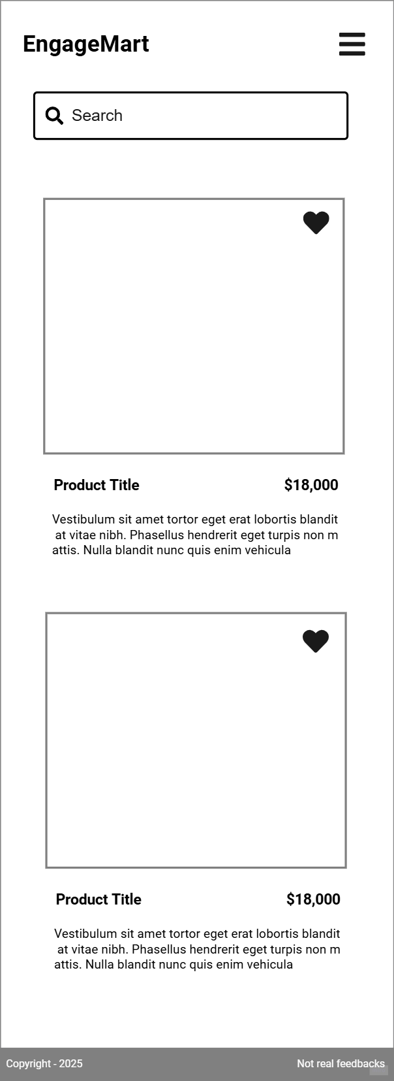 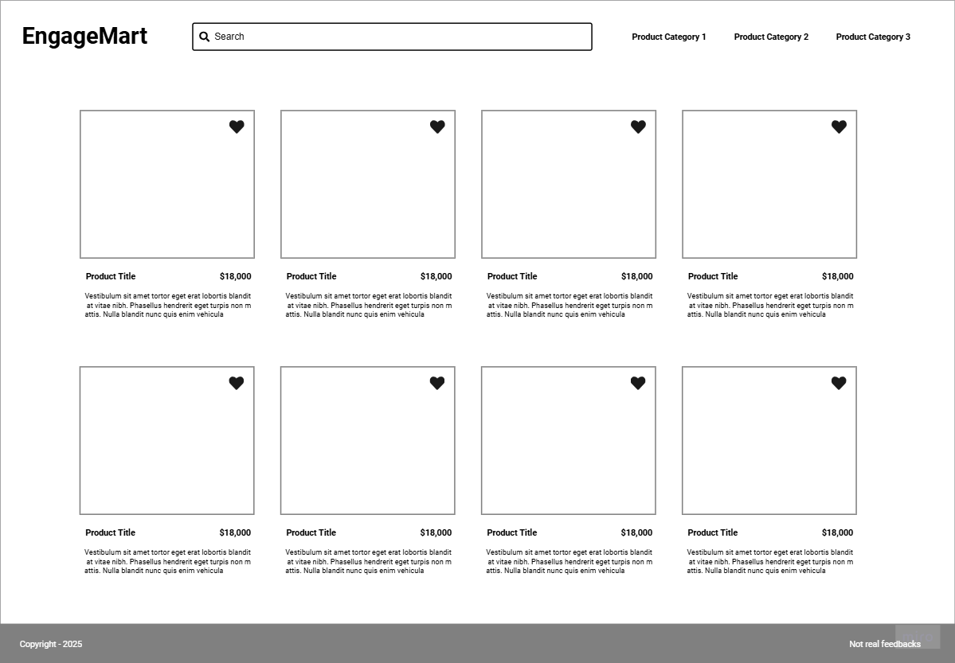

**External Data**

**FakeStoreAPI** - Provides product data (title, price, image, category).

**Supabase** – Data Storage, to store:

* Comments (text, user ID, product ID, timestamp).
* Likes (user ID, product ID).

**Module List**  
Module Overview

This project will be structured into several JavaScript modules that work together to create and manage EngageMart’s functionality. Below is a brief outline of each module:

1. Product Fetching Module
   1. Fetches product data from the Fake Store API.
   2. Parses and organizes data for display in the UI.
2. Supabase Integration Module
   1. Manages all communication with the Supabase backend.
   2. Handles saving and retrieving comments and likes from the database.
3. Comment & Like Module
   1. Provides functions to post new comments and register likes for a product.
   2. Updates the UI in real time based on user interactions and data retrieved from Supabase.
4. UI Rendering Module
   1. Dynamically generates product listings and user interaction elements (comment boxes, like buttons).
   2. Uses DOM manipulation to reflect real-time updates.
5. Main Application Module
   1. Coordinates the flow of data between fetching, rendering, and user interactions.
   2. Acts as the entry point, initializing other modules and controlling overall app logic.
6. Styling Modules
   1. Provide a seamless experience across mobile and desktop with intuitive navigation and clean layouts.

**Graphic Identity**

**Colors:**

* Primary: # #3d8c95
* Secondary: # #225675
* Background: # #e6873c

**Fonts:**

* Headings: Inter Bold
* Body: Inter Regular

**Icon:**

* A shopping cart merged with a speech bubble, to symbolize product interaction.

**Week Deliverables**

**Week 5**

* **Project Setup & Environment**
  + Organize files and folders
  + Set up a basic local server for easy testing and live reload.
* **Fake Store API Integration**
  + Fetch product data from [Fake Store API](https://fakestoreapi.com/).
  + Parse and display the products in a simple grid layout.
* **UI Design with Bootstrap**
  + Use Bootstrap’s grid system and components for a clean homepage design.
  + Ensure core UI elements (navigation, product cards, footer) are in place.

**Week 6**

* **Comments & Likes with Supabase**
  + Create functions in JavaScript to send and retrieve comment data to/from Supabase.
  + Implement a similar flow for likes, updating the like count in real time.
  + Design comment input fields and like buttons, integrating them into the product UI.
* **Refine UI Interactions**
  + Use DOM manipulation to show/hide comment sections.
  + Provide feedback after a successful comment or like.

**Week 7**

* **Search & Filter Features**
  + Implement a search bar for quick product lookup by name or category.
* **Responsive & Final Polish**
  + Test and adjust layouts across different screen sizes using Bootstrap’s responsive utilities.
  + Fine-tune styles, spacing, and visual cues for better user experience.
* **Deployment**
  + Deploy the static site to render.
  + Test all features (comments, likes, filtering) in the live environment and make any necessary fixes.

**Project Planning**

Trello Board Link: [EngageMart Trello Board](https://trello.com/invite/b/679b70d5cd17cede834f0df1/ATTI7d1af6598e97ecea0fc3dd61dc4d4be5EBE9A7A2/engage-mart)

**Challenges**

* Real-Time Comment Updates
  + The solution is to use Supabase’s real-time subscriptions.
* API Rate Limits
  + The solution will be to cache product data locally.
* Cross-Device Responsiveness
  + I will test layouts on multiple screen sizes.